Bipolar Junction Transistor Characterization HW (20 Points)
(jas, BJT Characterization HW.docx, 12/31/2024)

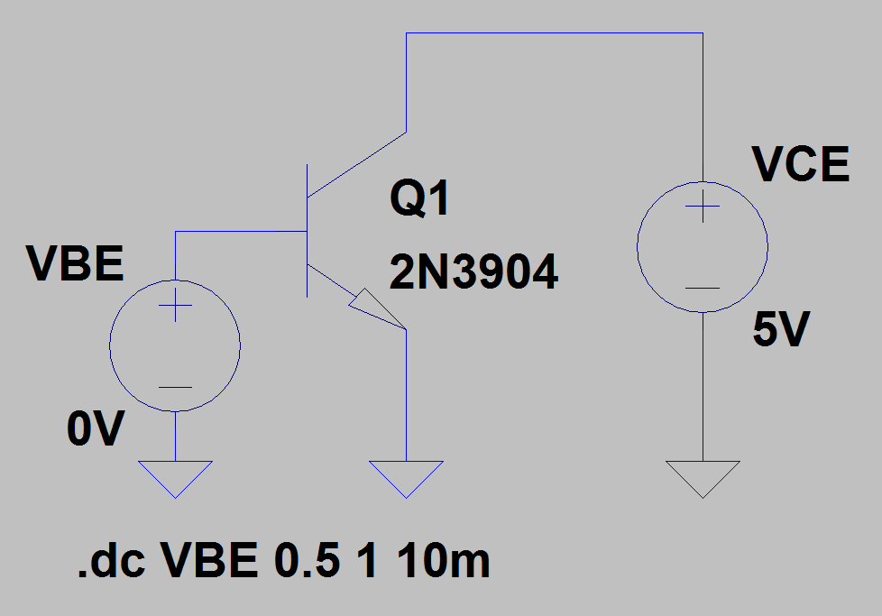
- npn Common-Emitter V_{BE} versus I_{C}: Use LTspice to characterize the 2N3904 npn transistor in the common-emitter configuration with a V_{BE} voltage sweep as illustrated in the adjacent schematic. The specific model for a 2N3904 is chosen by first placing an npn transistor, then hovering the cursor over the device until the hand symbol appears, then right clicking to enable a pane that allows you to Pick New Transistor, with a 2N3904 from NXP available from the pick list. The transistor type can also be changed simply by editing the value from NPN to 2N3904 on the schematic. Please consult the LTspice Help if questions arise. Connect up the adjacent circuit in LTspice and choose DC Sweep for analysis and implement the .dc statement as in the adjacent schematic.
Upon running the simulation, click on the resulting plot pane to activate the Waveform Viewer, followed by Plot Settings Add Plot Pane, which results in two plot panes with separate y-axis in the Waveform Viewer. Adding traces to the two plot panes is accomplished by clicking on either the top or bottom Plot Pane, followed by clicking on the Select Visible Waveforms icon to choose the desired waveforms to display on the two plot panes. Display Ic(Q1) in the top plot pane, and Ib(Q1) in the bottom plot pane, as shown below. Waveform colors can be changed in the plot pane from the default colors as desired. In the Waveform Viewer, attach the 1st cursor to the Ic(Q1) trace and adjust the horizontal cursor scale to 750 mV via the mouse and/or arrow keys to display the Ic(Q1) value at V_{BE} = 750 mV. Next attach the 2nd cursor to the Ib(Q1) trace and again adjust the horizontal cursor scale to 750 mV to indicate the Ib(Q1) value at V_{BE} = 750 mV. Then drag the cursor box onto the plot pane to document your simulated Ic(Q1) and Ib(Q1) value at V_{BE} = 750 mV. Also, annotate your plot pane with your name by means of the Plot Settings → Notes and Annotations → Place Text options available by accessing the Plot Settings pulldown menu above the toolbar. Replace the Ic(Q1) and Ib(Q1) curves below with your simulated results. (5 Points.)

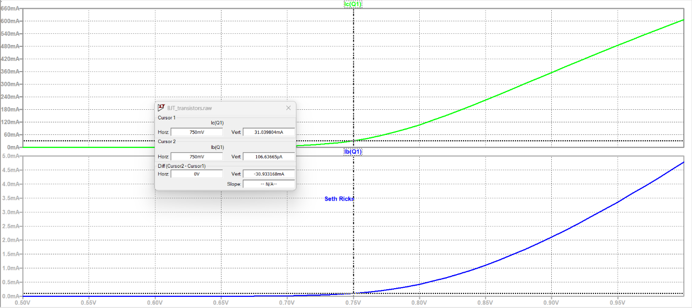

- Using the cursor values from the previous step and at least 3 significant figures, calculate and record below β_{dc} = I_{C}/I_{B} associated with your simulated I_{C} and I_{B} values at V_{BE} = 750 mV. (Hint: Your simulated β_{dc} should be between 290 and 294.)

I_{C} = 31.04 mA
I_{B} = 106.64 µA
Β_{dc} = I_{C/} I_{B} = 291.07 A

β_{dc} = 291.07 A (1 Point.)

- Which of the following statements best describes the information presented on your previous I_{C} and I_{B} versus V_{BE} graph for an npn bipolar junction transistor?

a. I_{C} and I_{B} both increase exponentially with increasing V_{BE}.
b. BJT circuit saturation occurs for V_{BE} < 0.7 V.
c. BJT active region operation occurs for V_{BE} < 0.7 V.
d. BJT active region operation occurs for V_{CE} ≤ 0.3 V.
e. Collector current is mostly independent of V_{CE} in the active region.

Answer: E (1 point.)

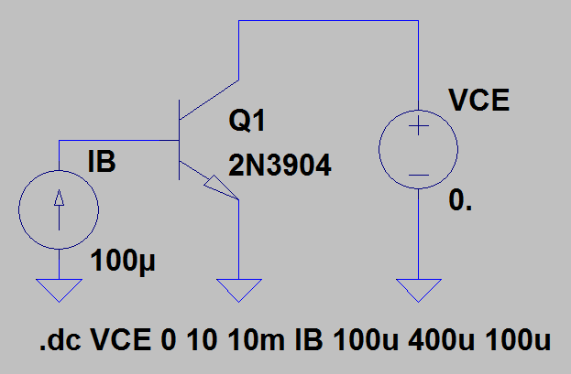
- npn Common-Emitter Family of I_{C} versus V_{CE} Curves: Next connect up the adjacent npn common-emitter circuit in LTspice and utilize a nested dc sweep to generate a family of I_{C} versus V_{CE} curves. Upon running the simulation, click on the resulting plot pane to activate the Waveform Viewer, followed by displaying the family of Ic(Q1) waveforms.

In the Waveform Viewer, attach both cursors to Ic(Q1). For multiple waveforms, the up/down arrow keys can be used to move the cursors from one waveform to the next, with each cursor having to be individually moved. keep one of the cursors on the Ic(Q1) trace corresponding to the smallest base current (I_{B} = 100 μA) while moving the other cursor to the Ic(Q1) trace corresponding to I_{B} = 200 μA. Adjust the horizontal cursor scales as needed with the mouse and/or arrow keys so that both cursors are located at V_{CE} = 5 V. Then drag the cursor box onto the plot pane to document your simulated values. Also, annotate your plot pane with your name by means of the Plot Settings → Notes and Annotations → Place Text options available by accessing the Plot Settings pulldown menu above the toolbar. Replace the Ic(Q1) curves below with your simulated results. (5 Points.)
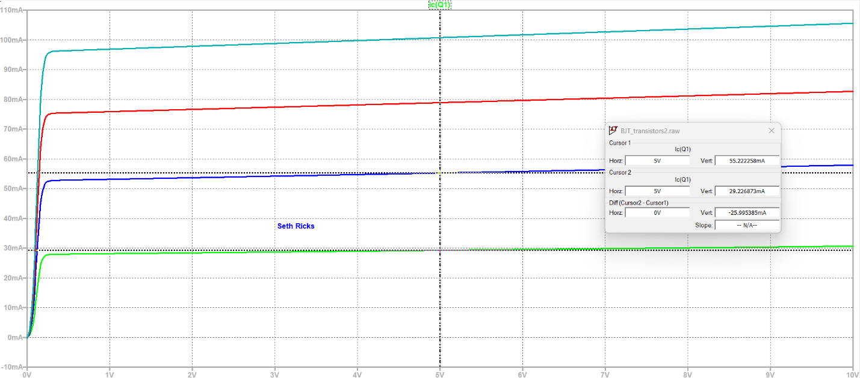

- Using the cursor values from the previous step and at least 3 significant figures, calculate and record below β_{ac} = ΔI_{C}/ΔI_{B} associated with your simulated ΔI_{C}/ΔI_{B} values in the previous plot pane. (Hint: Your calculated β_{ac} should be between 255 and 265.)
$ΔI_{c}=55.22 mA-29.26 mA=25.95 mA$; $ΔI_{B}=100 μA$
$$β=\frac{25.95 mA}{100 μA}=259.5$$
β_{ac} = $259.5$ (1 Point.)
- Which of the following statements best describes the information presented on your family of I_{C} versus V_{CE} curves for an npn bipolar junction transistor?

a. I_{C} and I_{B} both increase exponentially with increasing V_{BE}.
b. BJT circuit saturation occurs for V_{BE} < 0.7 V.
c. BJT active region operation occurs for V_{BE} < 0.7 V.
d. BJT active region operation occurs for V_{CE} ≤ 0.3 V.
e. I_{C} is mostly independent of V_{CE} in the active region.

Answer: E (1 point.)

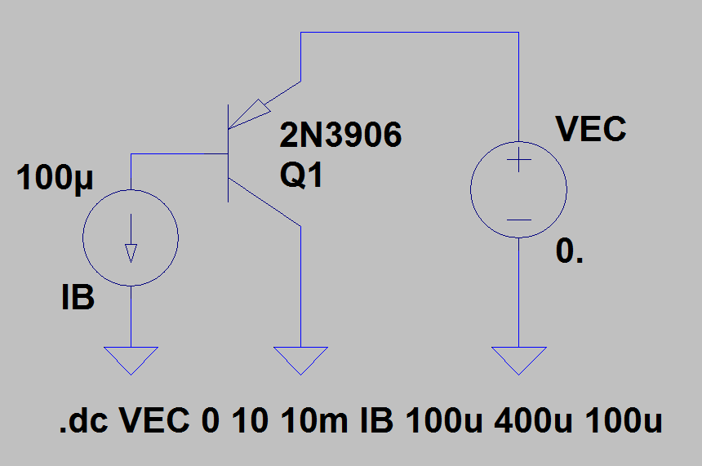
- pnp Common-Emitter Family of I_{C} versus V_{CEC} Curves: V_{CE} versus I_{C} Curves: Next connect up the adjacent pnp common-emitter circuit in LTspice and utilize a nested dc sweep to generate a family of I_{C} versus V_{EC} curves. The specific model for a 2N3906 is chosen by first placing a pnp transistor, then hovering the cursor over the device until the hand symbol appears, then right clicking to enable a pane that allows you to Pick New Transistor, with a 2N3906 from NXP available from the pick list. The transistor type can also be changed simply by editing the value from PNP to 2N3906 on the schematic.

Upon running the simulation, click on the resulting plot pane to activate the Waveform Viewer, followed by displaying the family of Ic(Q1) waveforms. In the Waveform Viewer, attach both cursors to Ic(Q1). For multiple waveforms, the up/down arrow keys can be used to move the cursors from one waveform to the next, with each cursor having to be individually moved. Keep one of the cursors on the Ic(Q1) trace corresponding to the smallest magnitude base current (∣I_{B}∣ = 100 μA), while moving the other cursor on the Ic(Q1) trace corresponding to ∣I_{B}∣ = 200 μA. (Note: SPICE, and therefore LTspice, assigns a negative sign to conventional currents flowing out of a terminal. Hence, the collector current is negative for a pnp BJT because conventional current flows out of the collector terminal.) Adjust the horizontal cursor scales as needed with the mouse and/or arrow keys so that both cursors are located at V_{EC} = 5 V. Then drag the cursor box onto the plot pane to document your simulated values. Also, annotate your plot pane with your name by means of the Plot Settings → Notes and Annotations → Place Text options available by accessing the Plot Settings pulldown menu above the toolbar. Replace the Ic(Q1) curves below with your simulated results. (5 Points.)
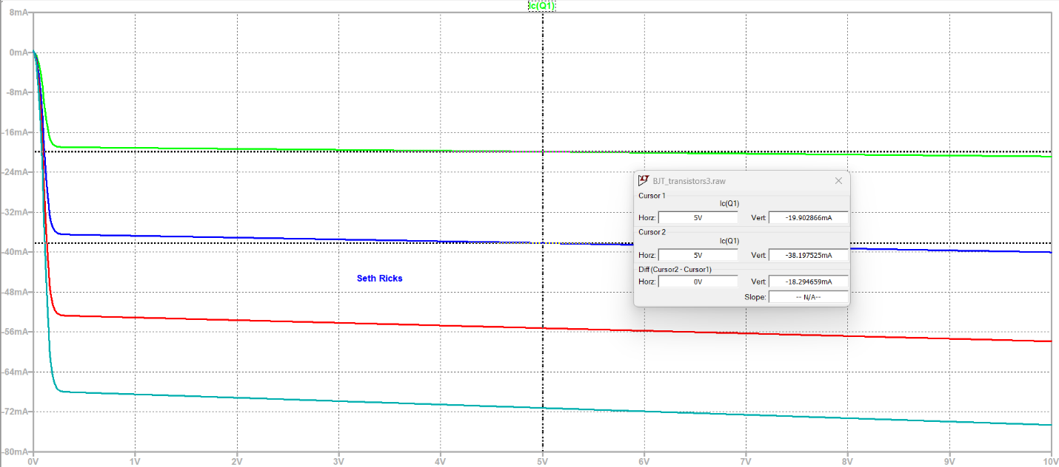

- Using the cursor values from the previous step and at least 3 significant figures, calculate and record below β_{ac} = ∣ΔI_{C}∣/∣ΔI_{B}∣ associated with your simulated ∣ΔI_{C}∣/∣ΔI_{B}∣ values in the previous plot pane. (Hint: Your calculated β_{ac} should be between 178 and 188.)

$$β_{ac}=\frac{ΔI_{c}}{ΔI_{B}}=\frac{18.3 mA}{100 μA}=183$$

β_{ac} = 183 (1 Point.)

